Project Sprint #4
The SOS game is described in CS449HomeworkOverview.docx. You should read the description very carefully.

Your submission must include the GitHub link to your project and you must ensure that the instructor has the proper access to your project. You will receive no points otherwise.

GitHub link: https://github.com/mohamede2022/SOS-game/tree/main/Sprint%204
Implement all the features that support a player (human or computer) to play a simple or general SOS game against another player (human or computer). The minimum features include choosing human or computer for red and/or blue players, choosing the game mode (simple or general), choosing the board size, setting up a new game, making a move (in a simple or general game), and determining if a simple or general game is over. The computer component must be able to play complete simple and general games. You are encouraged to consider basic strategies for winning simple or general games (e.g., against a poor human player). Optimal play is not required.

The following is a sample GUI layout. You must use a class hierarchy to deal with the computer opponent requirements. If your current code has not yet considered class hierarchy, it is time to refactor your code.

SOS Simple game General game Board size
8
Blue player  Human  S  O  Computer | 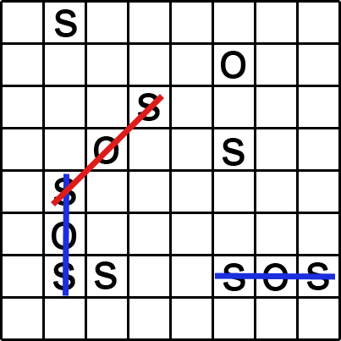 | Red player  Human  S  O  Computer
 | Current turn: blue (or red) | New Game

Figure 1. Sample GUI layout of the working program for Sprint 4
Total points: 24

- Demonstration (8 points)

Submit a link to a video of no more than five minutes, clearly demonstrating that you have implemented the computer opponent features and written some automated unit tests. No points will be given without a video link.
YouTube/Panopto link: https://umsystem.hosted.panopto.com/Panopto/Pages/Viewer.aspx?id=df62eb7c-f5cd-48a6-bb14-b39a003ad5a6
- A complete simple game where the blue player is a human, the red player is the computer, and there is a winner
- A complete general game where the blue player is the computer, the red player is a human, and there is a winner
- A complete simple game where both sides are played by the computer
- A complete general game where both sides are played by the computer
- Some automated unit tests for the computer opponent.

In the video, you must explain what is being demonstrated.

- User Stories for the Computer Opponent Requirements (1 points)

- User Story Template: As a <role>, I want <goal> [so that <benefit>]

ID | User Story Name | User Story Description | Priority | Estimated effort (hours)
8 | Play against Computer Opponent | As a player, I want to choose a Computer Opponent for either the Blue and/or Red player, so that I can play a single player game or watch the computer play against itself. | High | 12

- Acceptance Criteria (AC) for the Computer Opponent Requirements (4 points)
Add or delete rows as needed.

User Story ID and Name | AC  ID | Description of Acceptance Criterion | Status (completed, toDo, inPprogress)
8: Play against Computer Opponent | 8.1 | Player Type Selection & Startup  Given the user selects Computer for the Blue player and Human for the Red player in Simple mode, when the user clicks New Game, then the game starts, and the Blue Computer Player automatically makes the first valid move before prompting the human Red player. | completed
8: Play against Computer Opponent | 8.2 | Computer Winning Logic  Given it is the Computer Player's turn, and a position exists such that S _ S where placing an 'O' completes an SOS, when the computer calculates its move (get_move), then the computer chooses the move that completes the SOS, and its score increases. | completed
8: Play against Computer Opponent | 8.3 | Game Mode Agnostic Play  Given the board is partially filled, and the current player is a Computer in General Game mode, when the computer makes a move that scores an SOS, then the Computer Player's score increases, the turn does not toggle (it retains the turn) and the game is not over unless the board is full. | completed
8: Play against Computer Opponent | 8.4 | Computer Completes Game  Given a game is initiated with Computer vs. Computer in General Mode, when no human input is provided, then the game proceeds automatically until the board is full and a winner or draw is declared based on the final scores. | completed

- Summary of All Source Code (1 points)

Source code file name | Production code or test code? | # lines of code
board.py | Production code | 20
player.py | Production code | 120
SOSGame.py | Production code | 130
SimpleGame.py | Production code | 50
GeneralGame.py | Production code | 40
controller.py | Production code | 80
gui_main.py | Production code | 170
gui_board.py | Production code | 80
Test_board.py | Test code | 17
test_player.py | Test code | 14
test_controller.py | Test code | 15
test_gui_board.py | Test code | 10
test_game_simple.py | Test code | 60
test_game_general.py | Test code | 60
test_computer_player.py | Test code | 100
Total |  | 956

- Production Code vs New User stories/Acceptance Criteria (2 points)

Summarize how each of the new user story/acceptance criteria is implemented in your production code (class name and method name etc.)

User Story ID and Name | AC ID | Class Name(s) | Method Name(s) | Status (complete or not) | Notes (optional)
8: Play against Computer Opponent | 8.1 | SOSApp, GameController | SOSApp.create_widgets (for player type radio buttons), GameController.start_new_game, GameController.handle_computer_turn | complete | The GUI captures the player type and the controller initiates the computer's first move if it's set to Computer.
8: Play against Computer Opponent | 8.2 | ComputerPlayer | ComputerPlayer.get_move, ComputerPlayer.find_best_move | complete | find_best_move checks for all immediate winning moves first such as S_S or _O_ patterns and returns the first one found.
8: Play against Computer Opponent | 8.3 | GeneralGame, ComputerPlayer | GeneralGame.check_game_end, SOSGame.toggle_turn | complete | check_game_end in GeneralGame is a placeholder that does not change the game's over state, correctly allowing the computer to retain its turn upon scoring multiple times until the board is full.
8: Play against Computer Opponent | 8.4 | GameController | GameController.handle_computer_turn | complete | This method continuously calls the computer's move logic and updates the board, and if the next player is still a computer, it calls itself again or reschedules the move until a human player or game over is reached.

- Tests vs New User stories/Acceptance Criteria (2 points)
Summarize how each of the new user story/acceptance criteria is tested by your test code (class name and method name) or manually performed tests.

6.1 Automated tests directly corresponding to some acceptance criteria

User Story ID and Name | Acceptance Criterion ID | Class Name(s) of the Test Code | Method Name(s) of the Test Code | Description of the Test Case (input & expected output)
8: Play against Computer Opponent | 8.2 | TestComputerPlayer | test_winning_move_horizontal_s_o_s | Input: Board setup with 'S _ S' horizontally. Expected Output: Computer chooses to place 'O' in the middle.
8: Play against Computer Opponent | 8.2 | TestComputerPlayer | test_winning_move_diagonal_o_center | Input: Board setup with 'S' and 'S' diagonally leaving 'O' in the center open. Expected Output: Computer places 'O' in the center to score.
8: Play against Computer Opponent | 8.2 | TestComputerPlayer | test_no_winning_move_random_s | Input: Board partially filled, no SOS possible. Expected Output:Computer returns a valid, random move using its default letter ('S').
8: Play against Computer Opponent | 8.4 | TestComputerPlayer | test_auto_complete_simple_game | Input:SimpleGame with two Computer Players. Expected Output: Game over is True, a winner is declared and the game ends after a minimal number of turns.

6.2 Manual tests directly corresponding to some acceptance criteria

User Story ID and Name | Acceptance Criterion ID | Test Case Input | Test Oracle (Expected Output) | Notes
8: Play against Computer Opponent | 8.1 | Select Blue: Computer, Red: Human. Start a 3x3 Simple Game. | The Blue computer makes the first move automatically. The turn label immediately changes to 'Red'. | Confirmed the computer takes the first turn.
8: Play against Computer Opponent | 8.3 | Select Blue: Computer, Red: Human. Start a 5x5 General Game. Set Blue letter to 'O'. | Wait for the Computer to make a move that scores completing S-O-S. The computer’s score should increase, and the turn remains 'Blue'. | Verified computer retained turn in General Mode upon scoring.
8: Play against Computer Opponent | 8.4 | Select Blue: Computer, Red: Computer. Start a 3x3 General Game. | The game plays out instantly without any clicks, and the final status shows the winner and scores example (“Game Over! Winner: Blue (Blue Score: 2, Red Score: 1)"). | Confirmed full game automation.

6.3 Other automated or manual tests not corresponding to the acceptance criteria

Number | Test Input | Expected Result | Class Name of the Test Code | Method Name of the Test Code
1 | Test GeneralGameturn retention. | Player scores one SOS, retains turn, and game continues. | TestGeneralGame | test_multiple_sos_scoring_and_turn_retain
2 | Test SimpleGamedraw condition. | Board fills up with no SOS. Game ends in "Draw." | TestSimpleGame | test_draw_condition_3x3
3 | Test GameControllerinitialization. | Controller initializes SimpleGame with correct size and is an instance of SimpleGame. | TestController | test_new_game_flow_simple

- Present the class diagram of your production code (3 points) and describe how the class hierarchy in your design deals with the computer opponent requirements (3 points)?
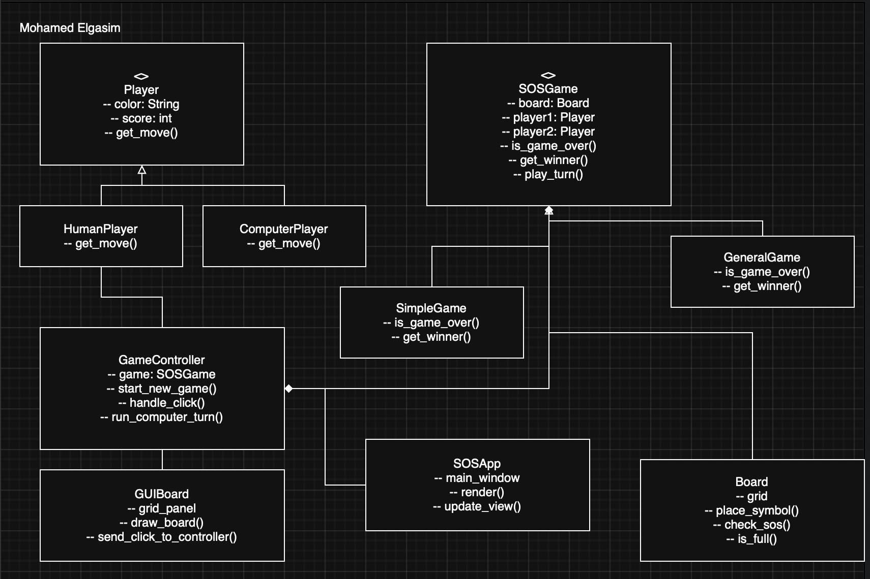
Note: I created it using Draw.io

1. The Player Hierarchy (Strategy Pattern)
This is how I handled moves from humans and computers without making the rest of the code messy.
- Player (Base Class): This is the main class that everything inherits from. It holds the player's basic info like color, score, and what letter they chose. It defines the abstract function to get a move (get_move()).
- HumanPlayer (Subclass): A simple class that inherits from Player. Its get_move() is basically waiting for a click from the GUI (GUIBoard).
- ComputerPlayer (Subclass): This is where the AI logic lives. It inherits from Player and implements a real get_move() function that runs our basic winning strategy.
This meets the computer opponent requirements because in the SOSGame class, we never say "If it's a human, do X, if it's a computer, do Y." We just call current_player.get_move(). Because of polymorphism, Python automatically runs the right move logic, human waiting for click or computer running its strategy. This is a clean way to handle the computer opponent requirement.

2. The Game Hierarchy
I needed different rules for Simple vs. General games.
- SOSGame (Abstract Base Class): This handles common stuff like checking for SOS patterns (check_for_sos) and making moves. It acts as a template for the game flow.
- SimpleGame (Subclass): Implements the Simple rules, so if an SOS is scored, the game ends immediately overriding methods like check_game_end.
- GeneralGame (Subclass): Implements the General rules so the player who scores retains the turn and the game only ends when the board is full.

3. MVC Components
- Model: Board, Player and its subclasses, SOSGame and its subclasses.
- Controller: GameController. It is responsible for starting new games, translating user input, and managing the computer player's turn flow. It composes the SOSGame object.
- View: SOSApp (the main window) and GUIBoard (the grid panel). They interact with the GameController (shown with a simple association line in the diagram) to display the game state and handle user clicks.

